Data Guard Administration and Client Connectivity in Data Guard Configuration
Generate log switches on Primary
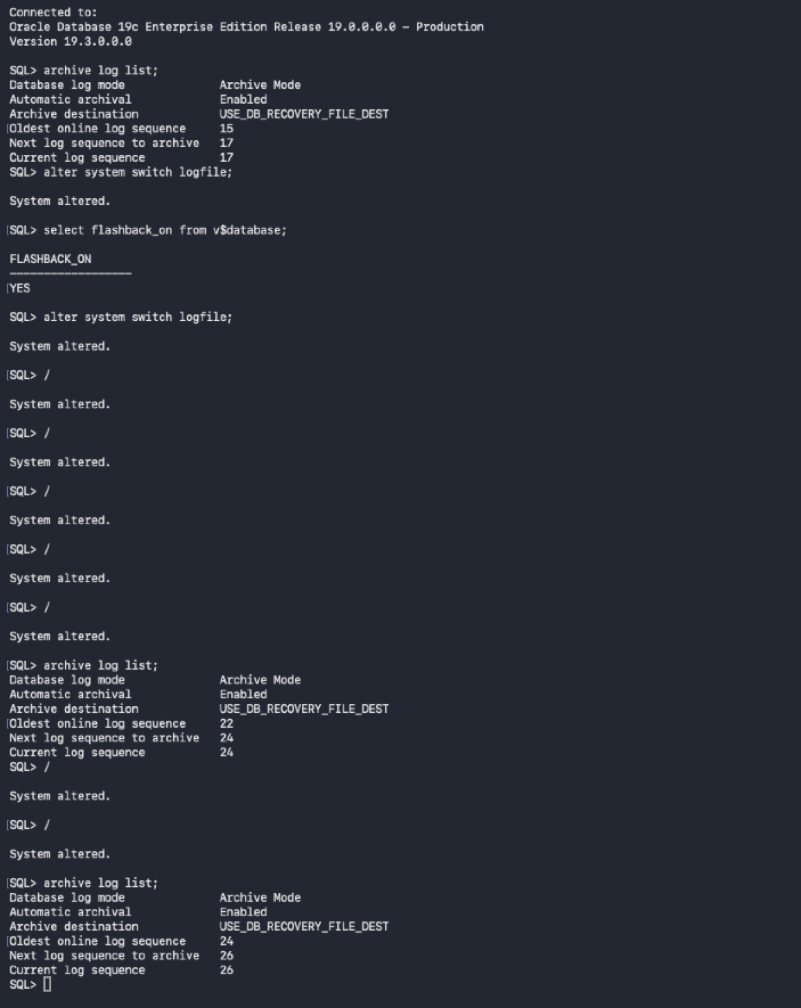
Stop MRP process on standby:
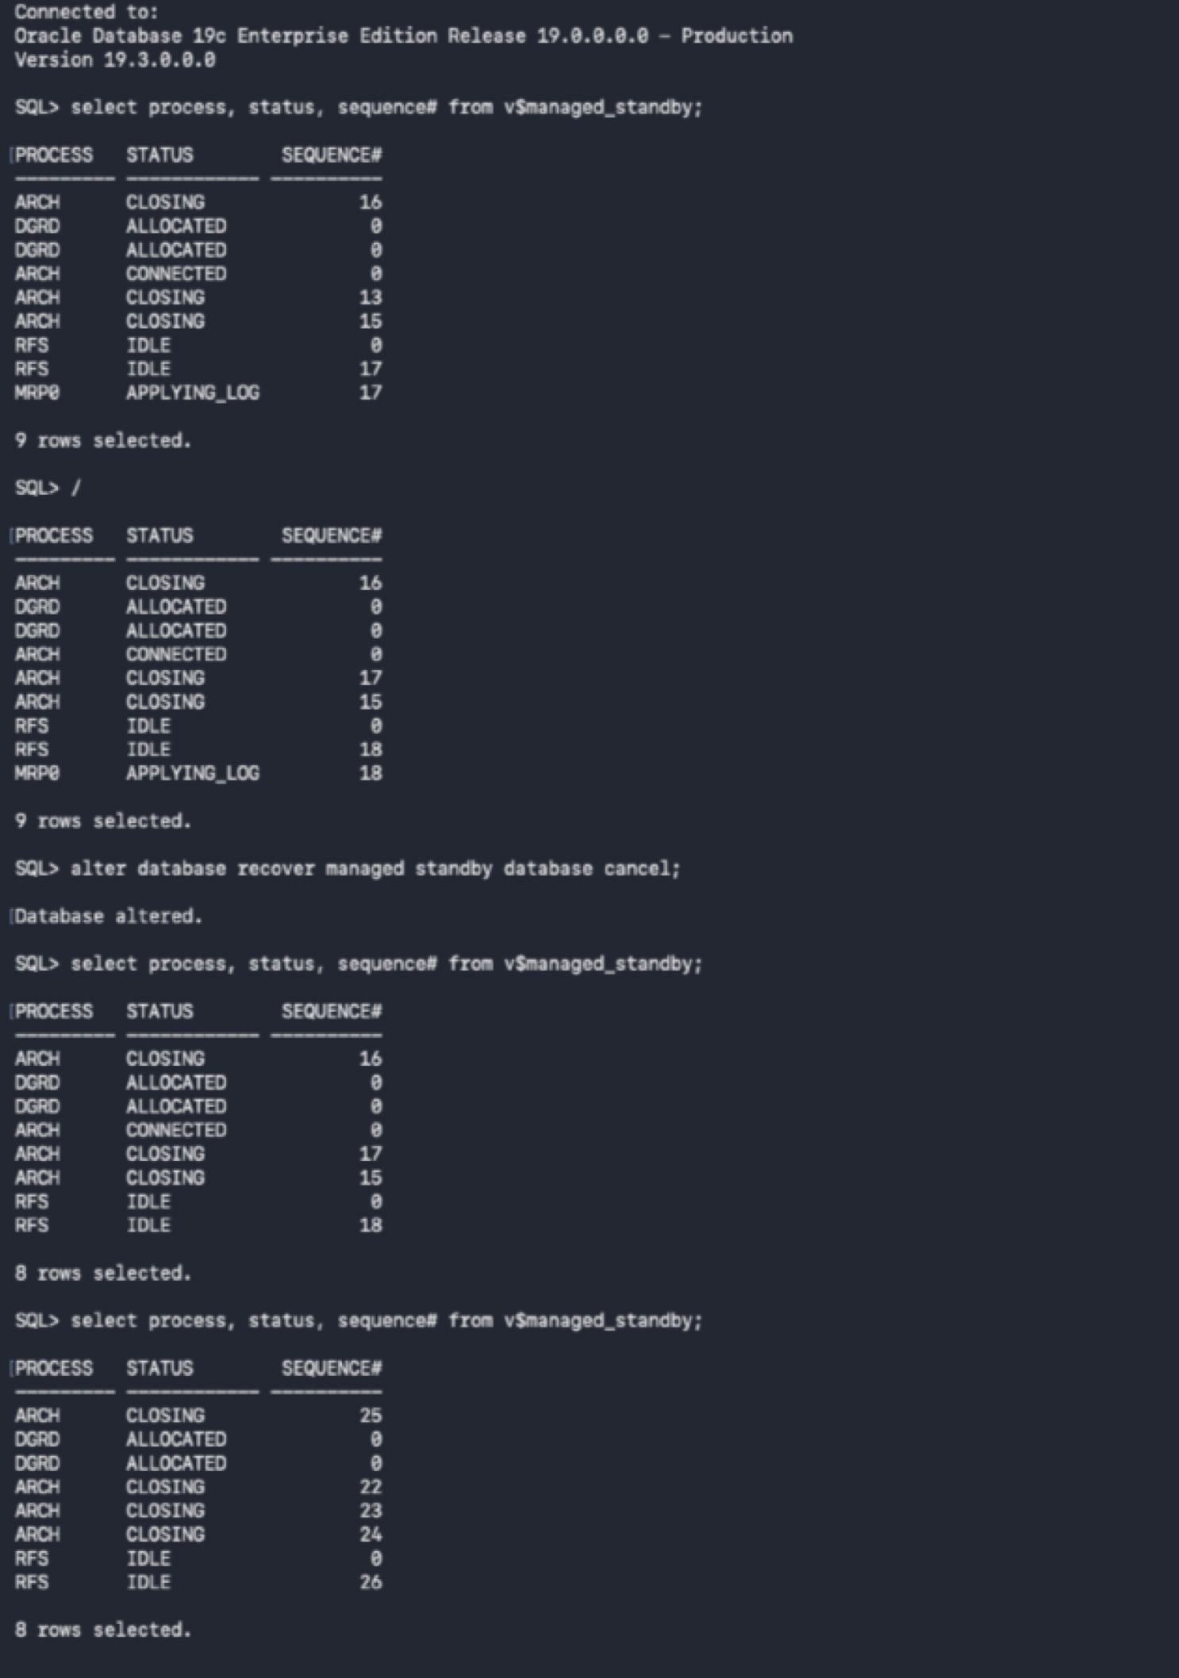
Start MRP process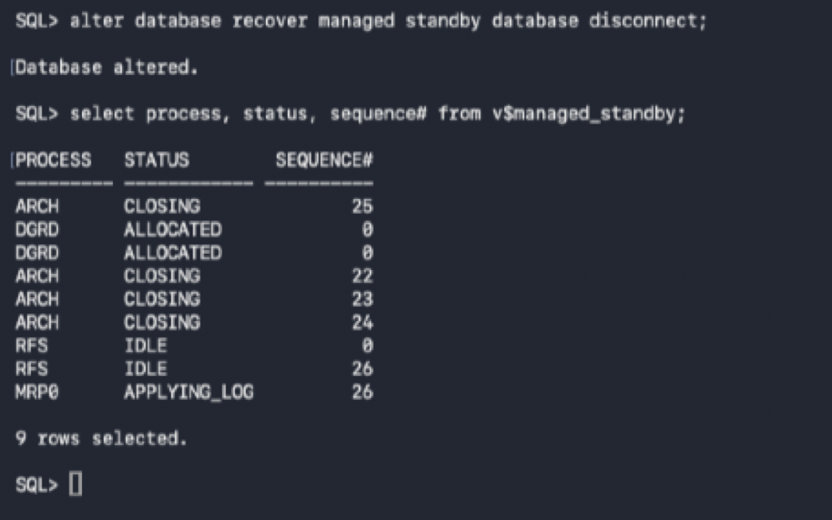

Stop Log shipping service:
Stop logs from being sent to the standby database
alter system set log_archive_dest_state_2='DEFER';
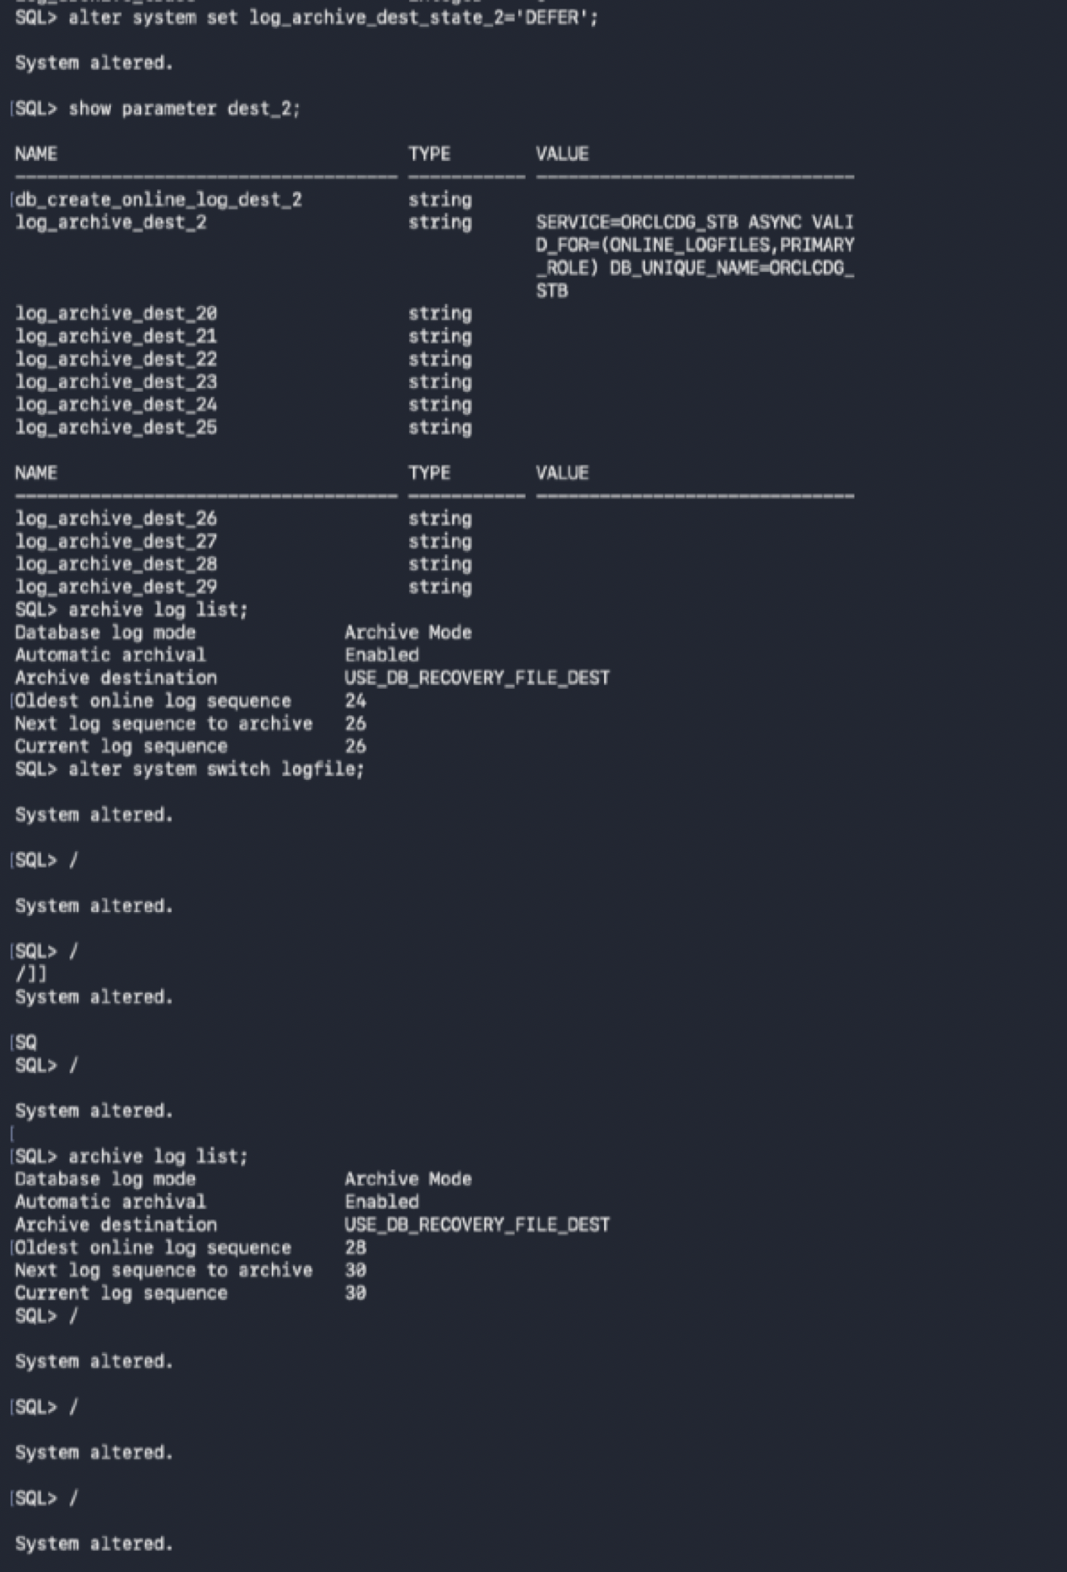
Standby
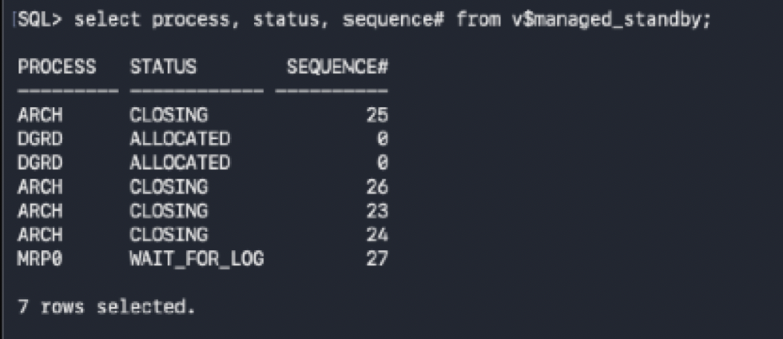

Enable log shipping again and verify that these no gap
alter system set log_archive_dest_state_2='ENABLE';
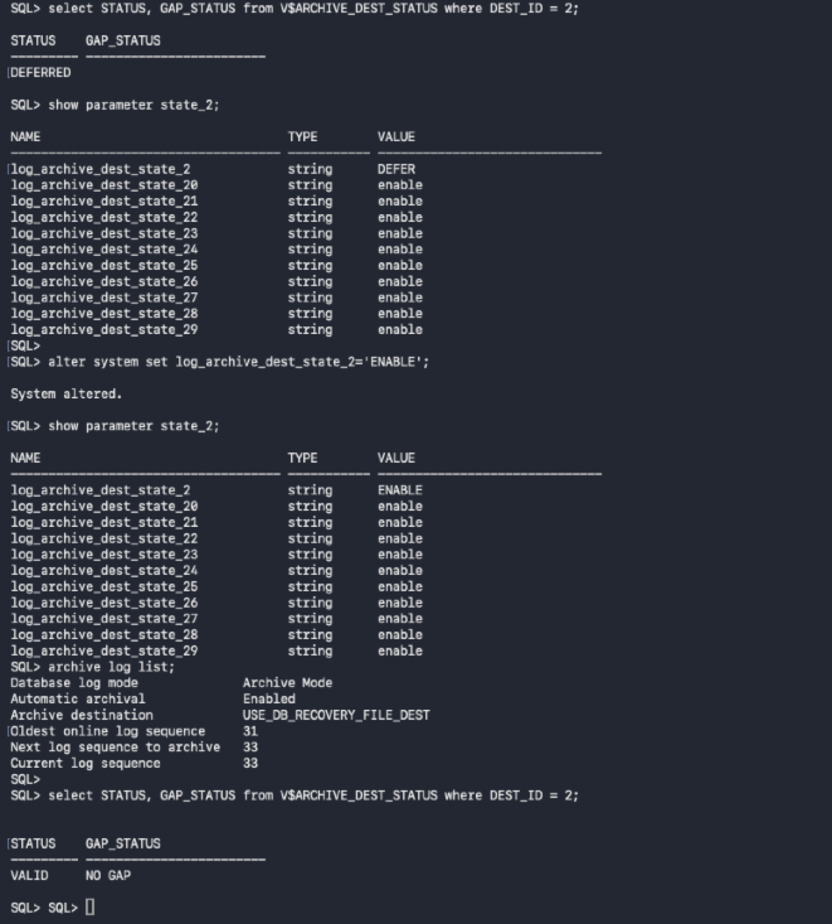

Standby
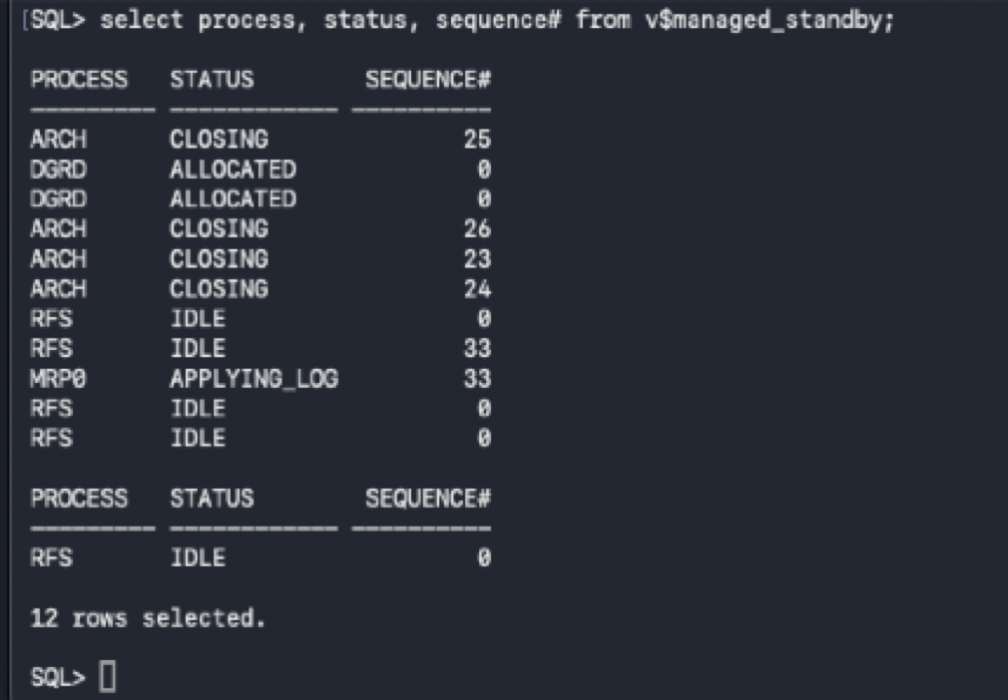

How to cleanly bring down standby database and apply service.
- Stop MRP process
- Shutdown database
Logs will be shipped to standby, but they will not be applied
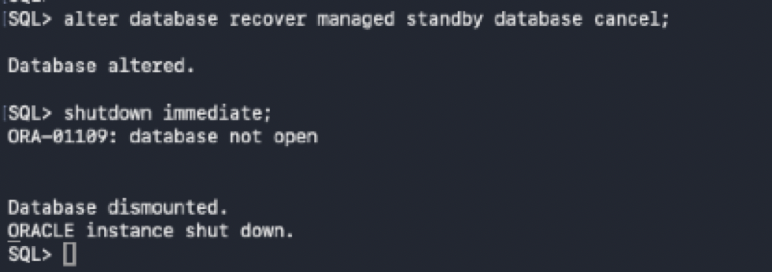

Start standby database in mount state and start MRP apply service again
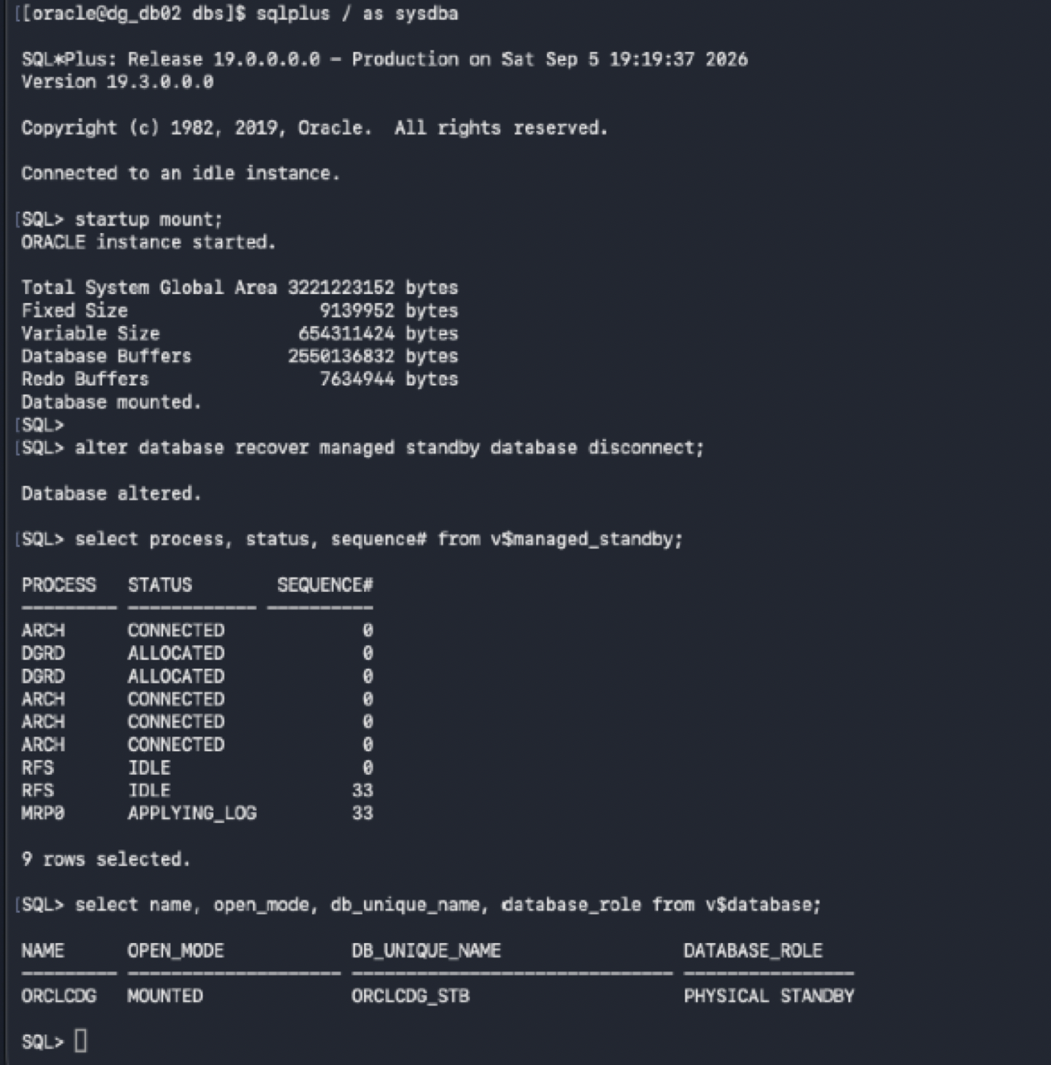

Verify there’s no gap after stopping and starting standby database.
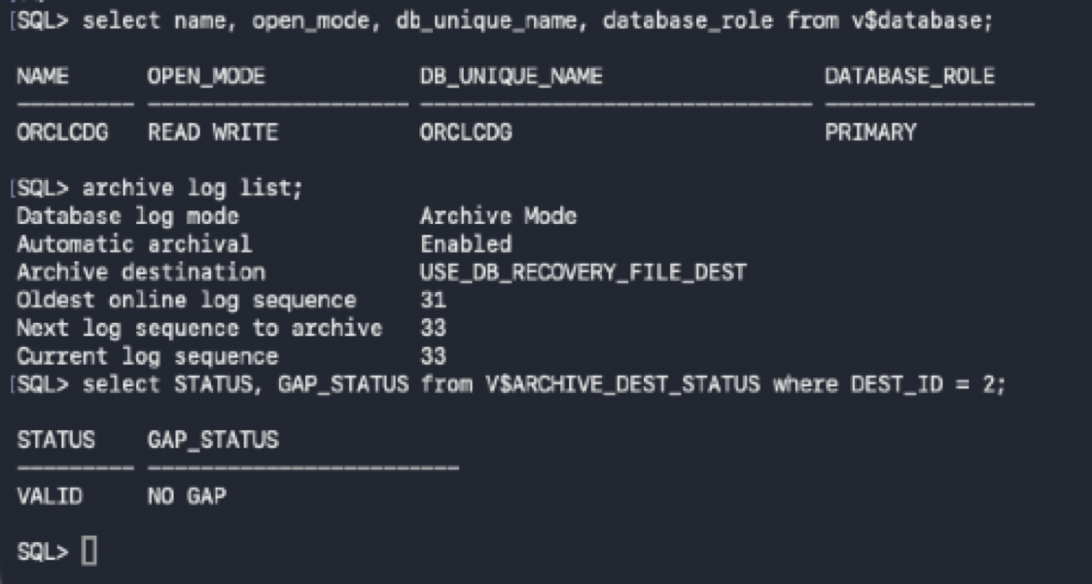

Client Connectivity in Data Guard Configuration
- Create a Service on the Primary database so when you perform a switchover or failover, client can smoothly connect to the new primary database in the data guard configuration
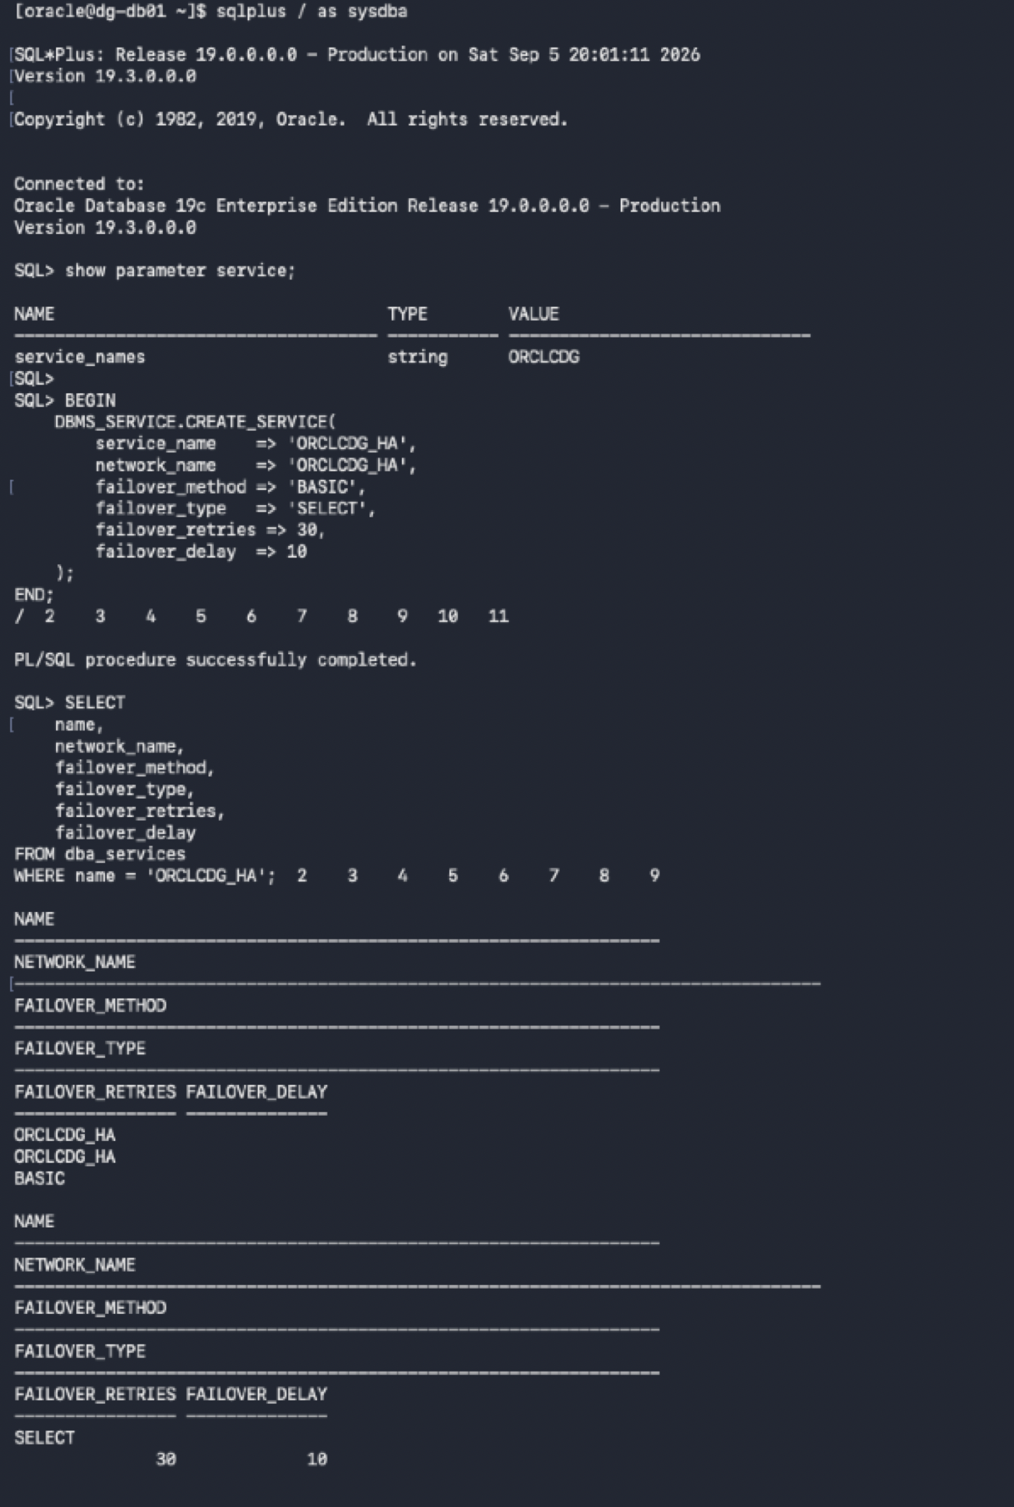

- create a small PL/SQL procedure that starts ORCLCDG_HA only when the database is PRIMARY and then have the startup of the database trigger call that procedure.
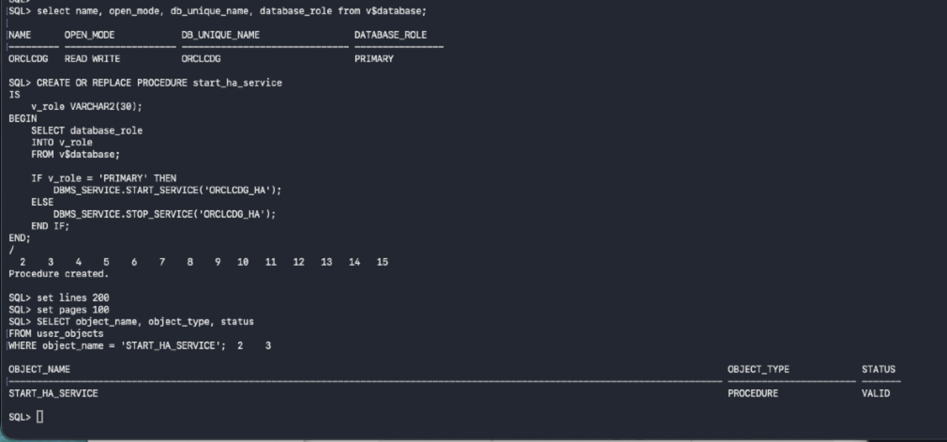

- Create 2 triggers that starts ORCLCDG_HA whenever the database opens, based on the database role, so you don't have to manually start it after every restart or role change, and a trigger that handles a switchover/failover role transition
The trigger gets executed when the database with the role as primary database starts up
